CUPE National Convention 2015
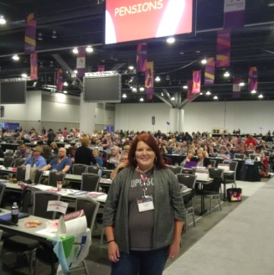
On Sunday November 1st 2015, the 5 CUPE Local 998 Delegates registered to represent our membership to the National body of our Union. This was day one of six long but rewarding days in Vancouver BC, filled with many noteworthy keynote speakers, contentious debates, and strong union spirit. This first day allowed us to participate in several caucuses relevant to our work. These were the Energy Sector, Crown Corporations, and MB/SK caucuses and attending allowed us to share similar viewpoints on specific issues, discuss upcoming resolutions, and meet with other locals who faced similar workplace concerns.
Kelli Howell,
Chief Steward with convention floor
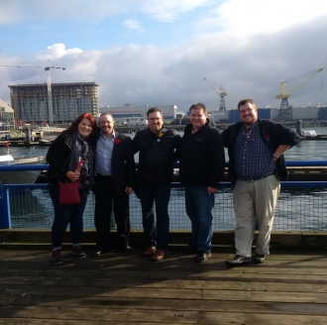
From Monday to Friday, the convention floor was filled with speakers, motions, and debate which ran from reserved, to austere, to cheers, to jeers. Through it all, your delegates considered every motion carefully, discussed it as a group, didn’t vote against each other, and acted as a team. Some of the more lively debates came from three areas: the election of a new CUPE National President, a constitutional amendment to add four new vice diversity presidents (disability, LGBT, woman, and young worker), and a resolution to change strike pay to take effect from day 1. Your delegates considered every matter closely and even created opportunity to meet with both presidential candidates personally prior to the election vote.
Your CUPE 998
Delegates, taking a lunch break
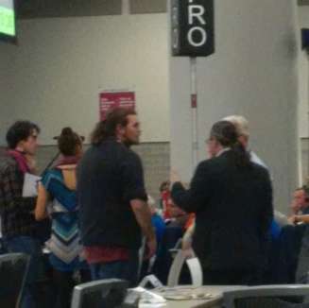
The resolution we felt most in favour of was strike pay from day 1. This, we felt, would be something our members would be able to feel directly should we ever approach a strike. It would also be a valuable negotiating tool prior to reaching that point. Unfortunately, even though we supported it, 35 members of the 1600 voting delegates that day was the difference in voting that down. Thankfully, due to directions set by our own Strategic Planning and Executives team, we plan to have our own strike pay from day 1 plan in place.
Chris Mravinec,
998 President
providing funding levels of day 1 strike pay to a speaker
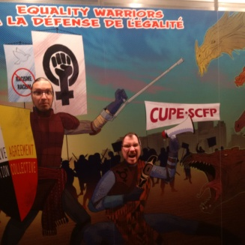
These days were 9 AM to 6 PM, with additional meeting/caucuses with topics such as aboriginal, woman, young workers, pension, equality, and other specific issues that can affect our members. Your team of Delegates also met for meals to discuss the matters of the day, the upcoming resolutions, constitutional amendments, and convention matters.
Mike Kubrakovich, Treasurer &
Denis Côté, VP at the Equality Booth
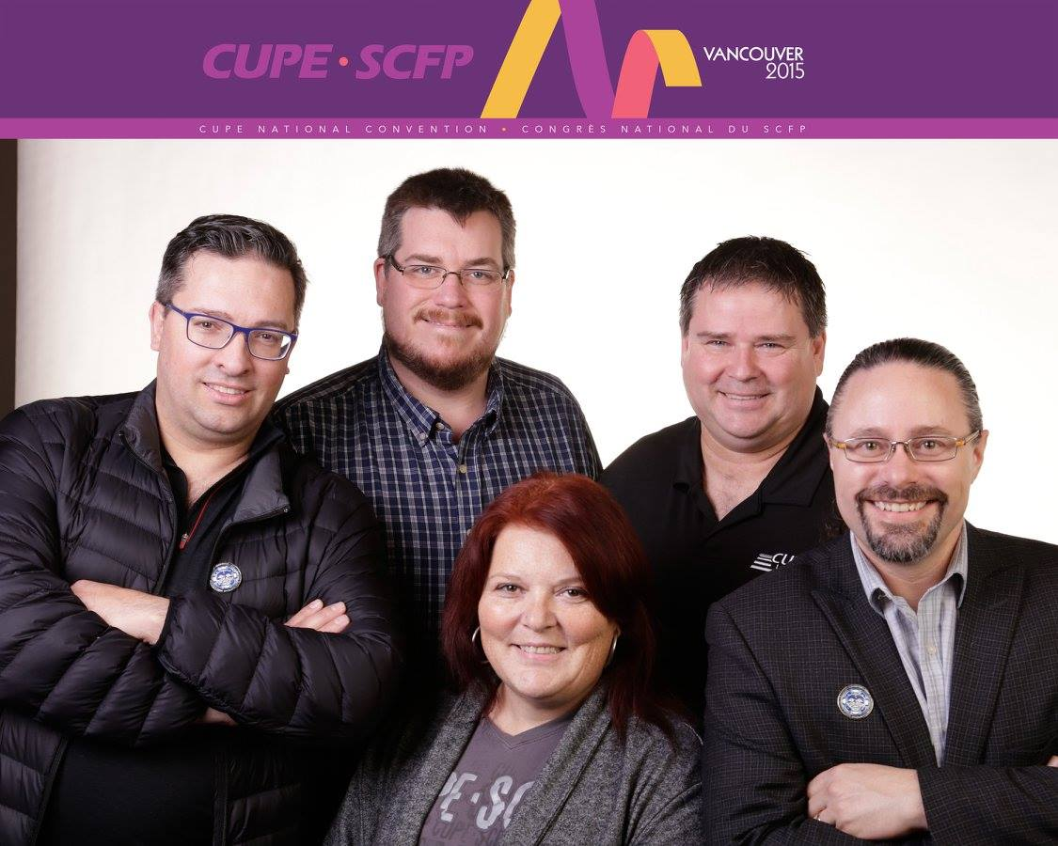
Your Delegates were a strong functioning team, able to openly debate amongst ourselves but also able to keep a positive attitude. While the convention itself was long, the experience was rewarding and we felt like we had a positive impact on our union.
Your CUPE Local 998 Delegates (L-R):
Mike Kubrakovich, Treasurer; Denis Côté, VP; Kelli Howell, Chief Steward; Darryl Forbes, Executive At Large; Chris Mravinec, President.

